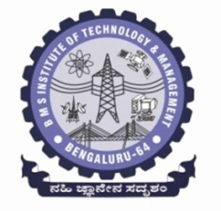**BMS Institute of Technology and Management**

**(An Autonomous Institution, Affiliated to VTU, Belagavi)**

**Department of Master of Computer Applications**

**(Accredited by NBA, New Delhi)**

**Alternate Assessment Tool (AAT) #**

|  |  |  |  |
| --- | --- | --- | --- |
| **USN** | 22MCA07 | **Student Name** | Anirudh U Parvatikar |
| **Course Code** | 22MCA107 | **Course Title** | Research Methodolody & IPR |
| **Semester** | 1st | **Academic Year** | 2022-23 |
| **Date of Submission** |  | **Number of Pages Submitted** |  |

|  |
| --- |
| **AAT Question or Topic or Problem Statement** |
| **Solution / Answer** |